Smartphone: Basics and hints

Introduction

A Smartphone is a phone with enhanced features beyond making and receiving a call.
Operating systems for a laptop or desktop are Windows, Mac OS, Linus and Chrome OS.
A Smartphone may or may not run on Android OS (Operating System).
There are other operating systems, like iOS (for iPhones), Windows OS etc. ... Most of the mobile manufacturers use Android as their OS.
The manufacturer of the Android OS is Google, from iOS it’s Apple.

What does the i stand for in Apple iOS?
In 1998, the “i” in iMac stood for Internet. ... Besides Internet, Apple's prefix also stood for individual, instruct, inform and inspire. Since then, the “i” has moved beyond its Internet-centric meaning; Apple probably didn't have the Internet in mind when naming the original iPod.

Manufactures who use Android in their smartphones: Samsung, LG, Sony, HTC, Huawei, Motorola, Google.
You can find the iOS in iPad, iPod Touch and iPhone.

In average, users change every 3 years their smartphone.

Google (with Android) guarantees software updates for two years. In general, after these three years you can install one update higher, e.g. from Android 9 tot Android 10.
So you an use your Android mobile for about 4 years.

Apple guarantees the software for 5 years.

If you keep your mobile for longer than 4 or 5 years, then you can’t install certain apps anymore, and your security isn’t sure anymore, it’s possible you will be hacked.

It’s how you are working with the machine that is very different with a smartphone comparing with a laptop/desktop. Think only at the finger touch and the slide movements !

Handling the screen
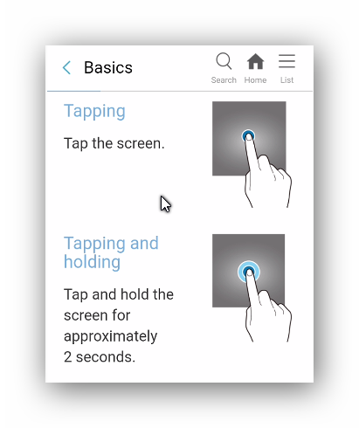
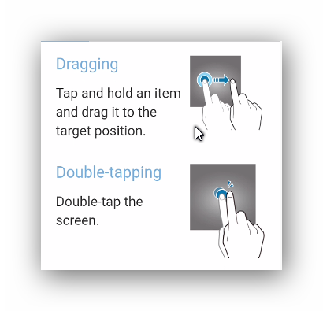
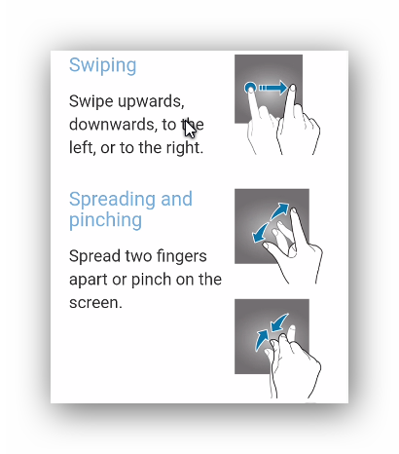
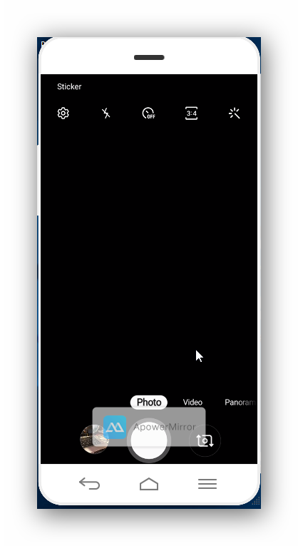
The Camera

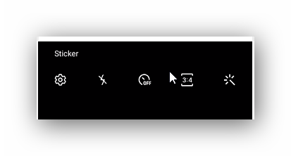
The Flash

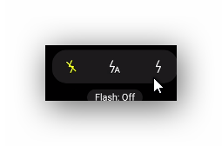

Switched off Automatic flash Always flash

The timer
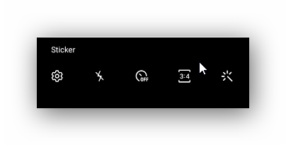

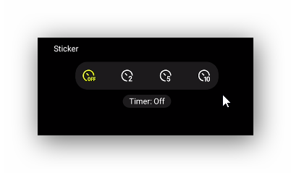

A delay of 2 5 10 seconds

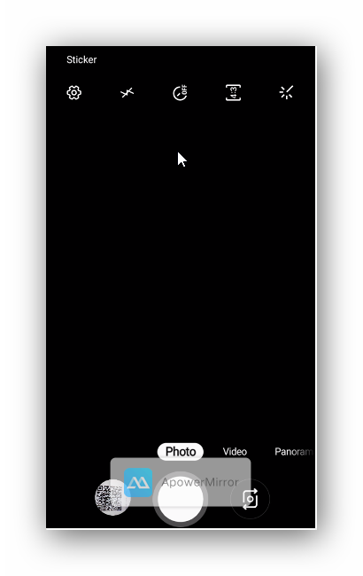
Photo, Video, Panorama, Continuous shot....
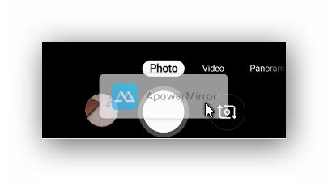
Front or back camera

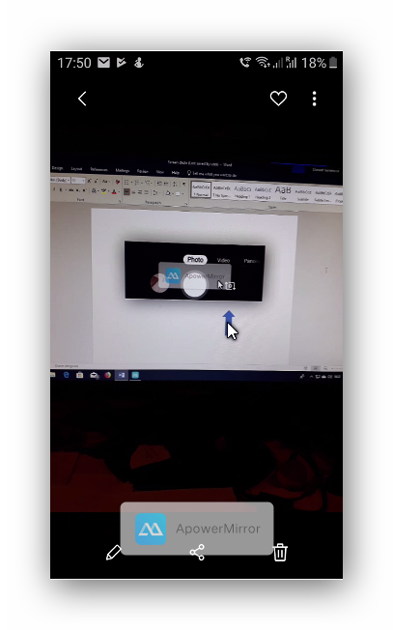
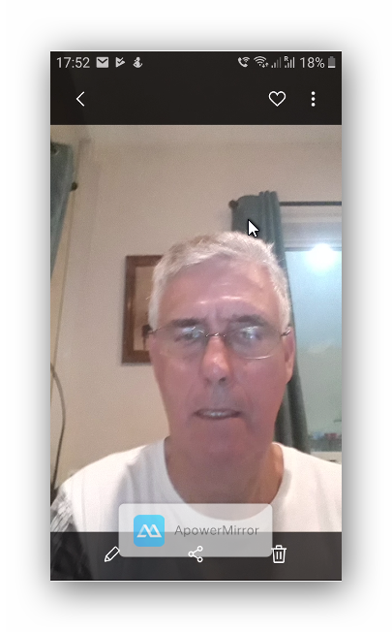

View of taken pictures
Enter text on photo

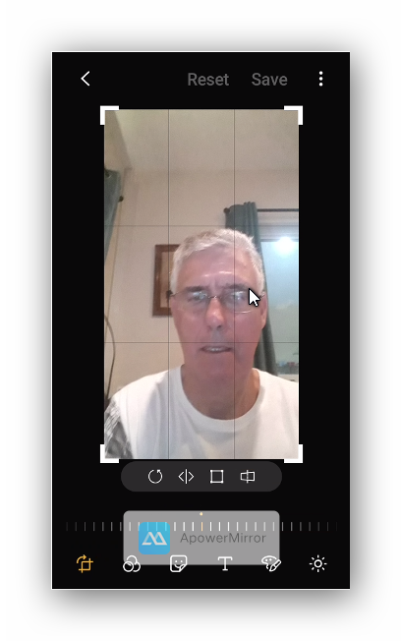

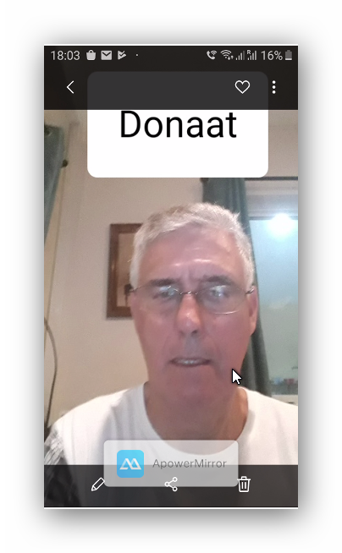
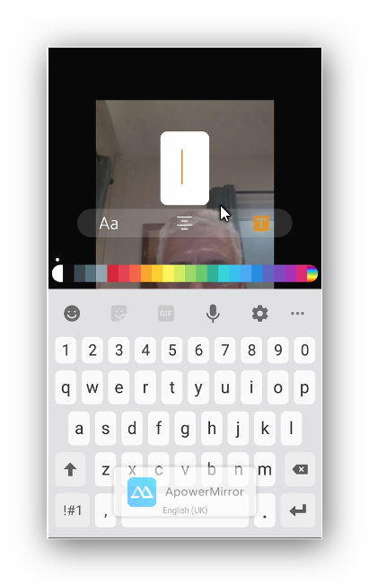
Type

Video recordings
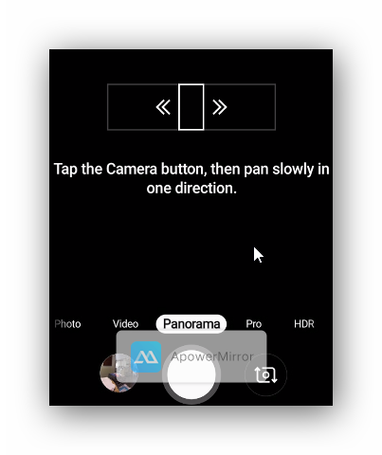
Panorama recording

Result 90 degrees turning

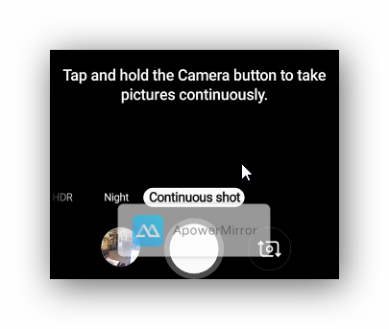
Continuous shot
Result 18 pictures

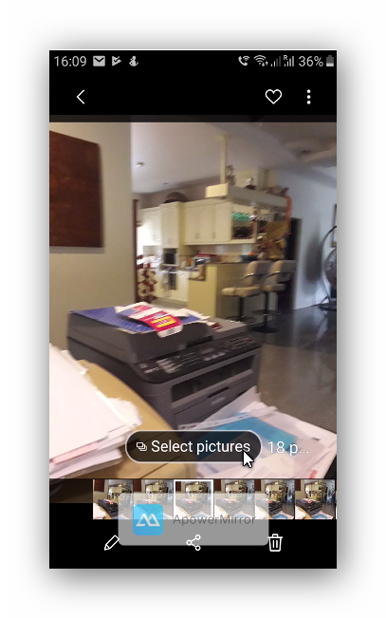

Where are the pictures stored?

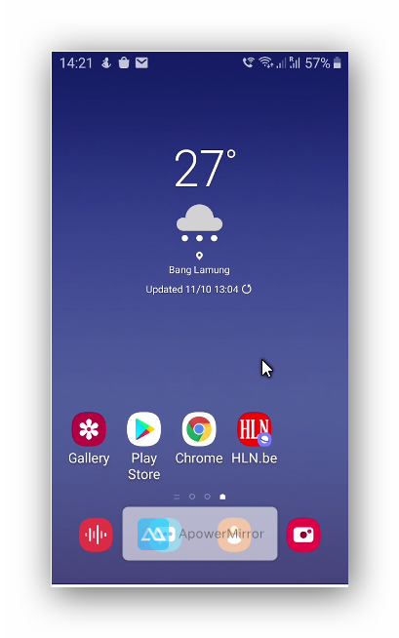

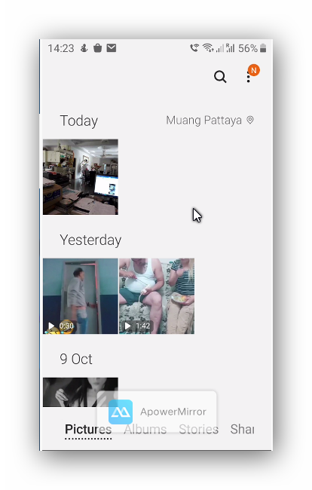

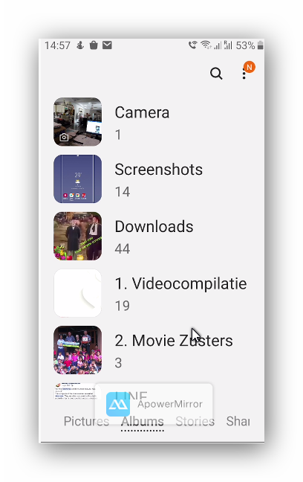
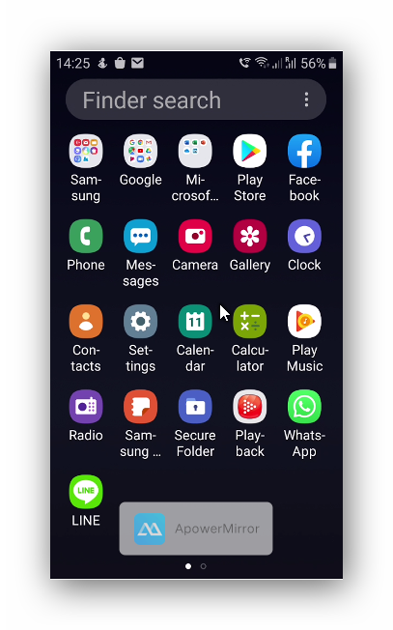
And

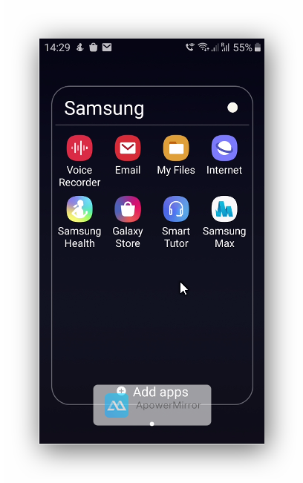

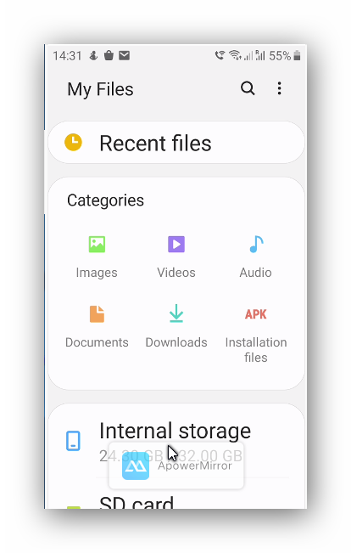

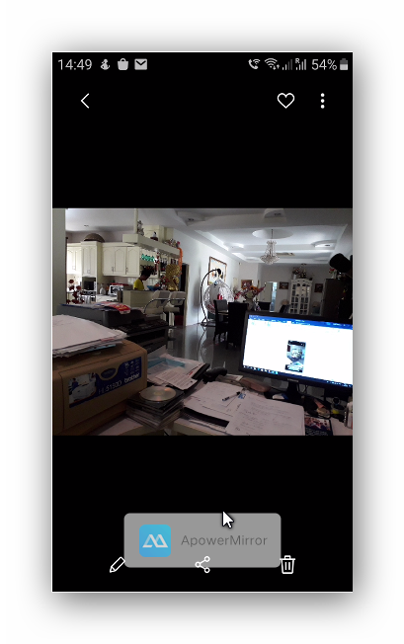
To send pictures with line, email…..
share
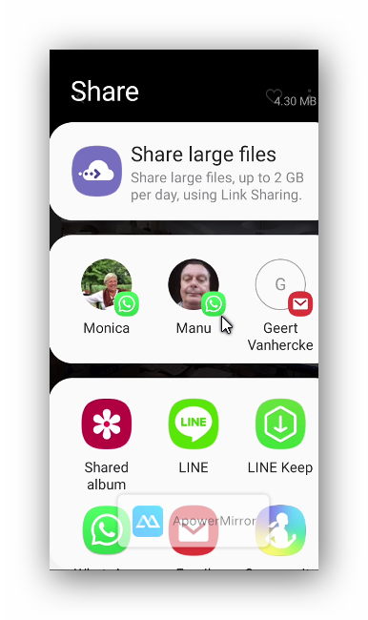

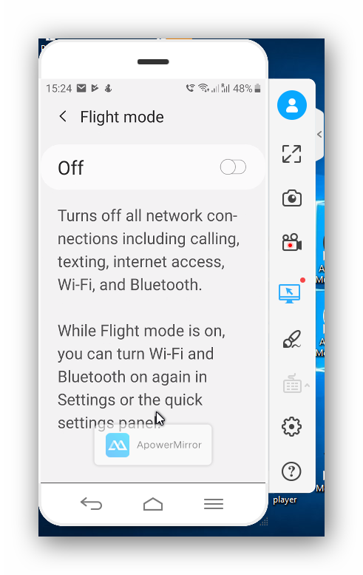
Miscellaneous

How to copy and paste

E.g. you want to copy the internet link below, here in a message in Whatsapp.
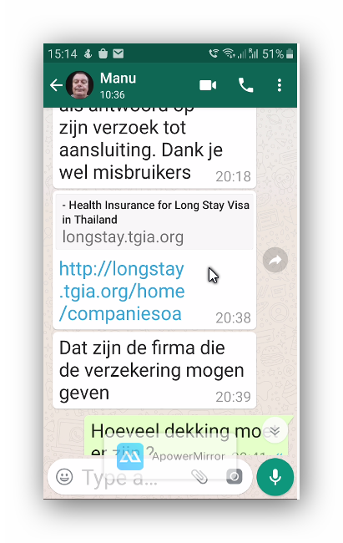
Tap and hold on the link: the text “copy” will appear.

Now tap and hold your finger on the place you want to copy the link, e.g. here on the cursor below in a message in Whatsapp for Brian:
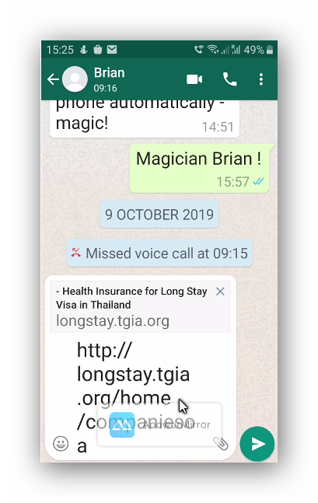

Another example: you want to copy a part of the text below.
Tap and hold the first word e.g. “Like”.

Then drag the right marker over the whole text you want to copy.
Then tap the left “copy” symbol.
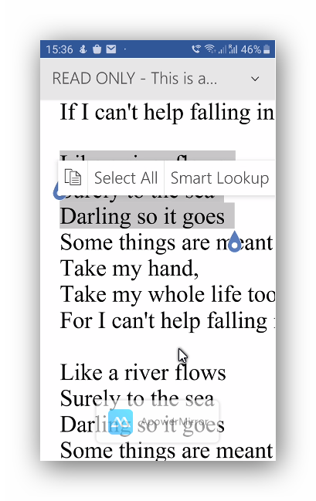

Now you can copy the text where ever you want it. E.g. here in an email message.
Tap and hold on the cursor.
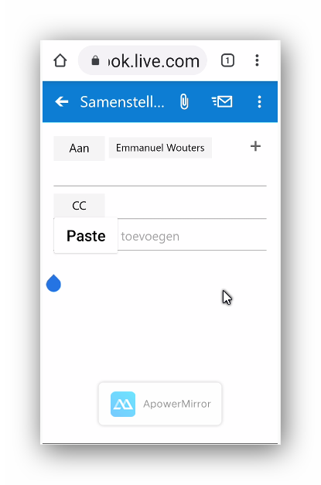

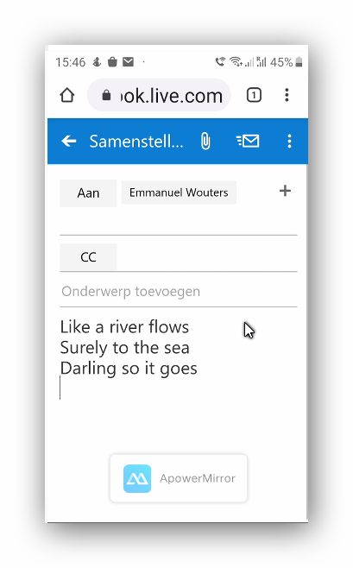
Tap on “paste”.

Enter text by voice
Demo

Wifi and Internet basics

Tap on “Settings”
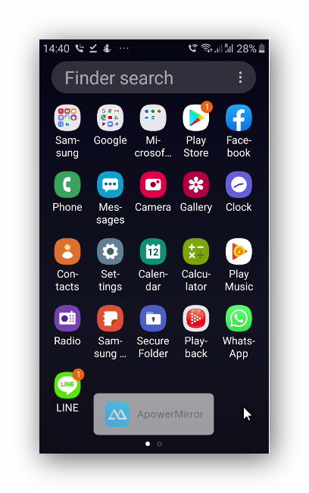

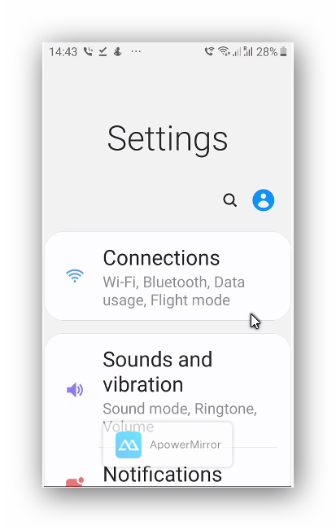
Tap on “Connections”

In the picture below Wifi is switched on.
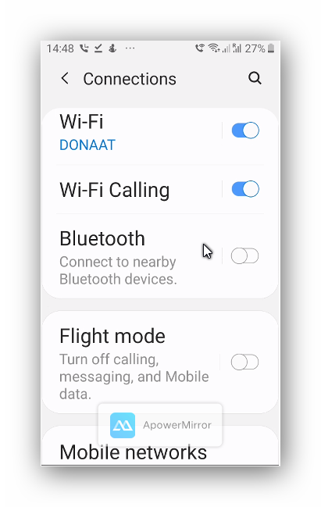
If you would like to connect with the internet because there’s no Wifi in range, swipe below “Mobile networks”.

Tap below on “Data Usage”
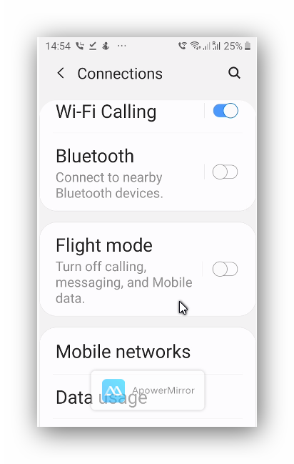
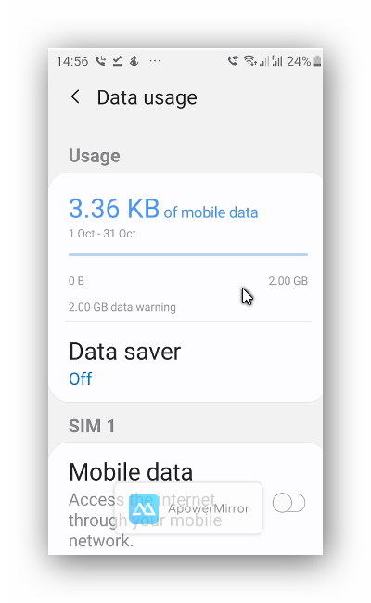

And tap below the switch next to “Mobile data” to connect with the internet.
Remark: in this way you will pay a lot for the internet connection, e.g. 2 bath/minute.
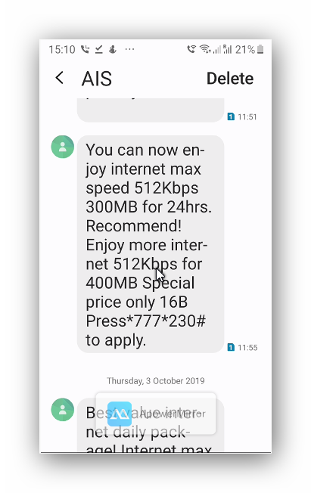
I get a lot of messages from AIS about purchasing a package e.g. for 24 hours:

But you could also purchase a monthly subscription for the use of internet with AIS.

